Report: Laboratory work 7

**Development of optimal smoothing to increase the estimation accuracy**

Team #1: Viktor Liviniuk, Alina Liviniuk

During this laboratory work algorithms to improve Kalman filter estimates were developed. That is of prime importance for many practical control and forecasting problems.

A trajectory of a moving object, disturbed by normally distributed unbiased random acceleration with variance 0.22 was generated with measurements. Kalman filter was developed. Then, backward smoothing was implied. Resulting data is plotted:

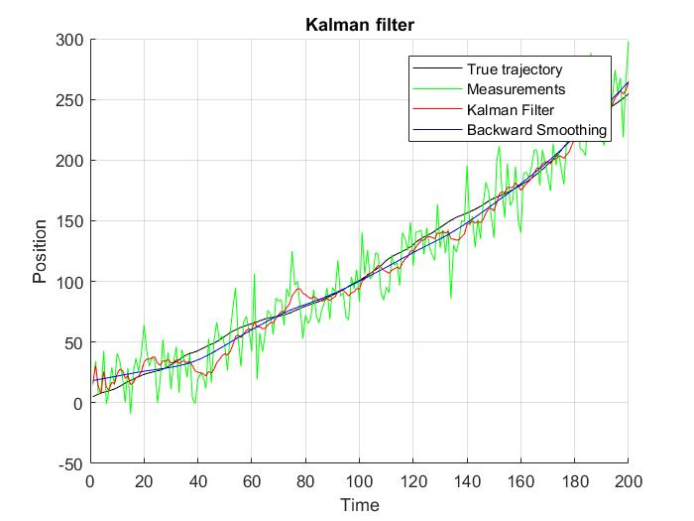

500 runs of smoothing were made to compare true estimation error with errors of smoothing.

The following two plots demonstrate correspondence of true estimation error with errors of smoothing for both x and V.

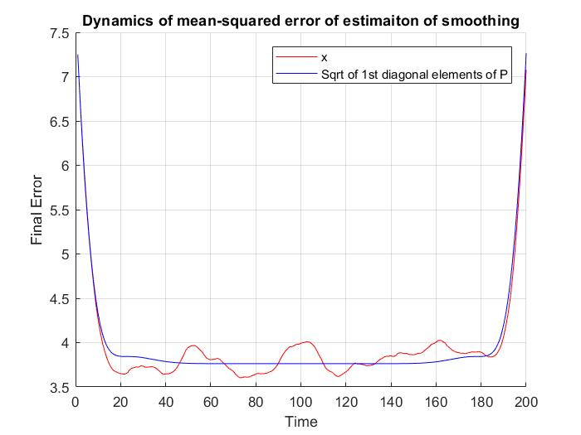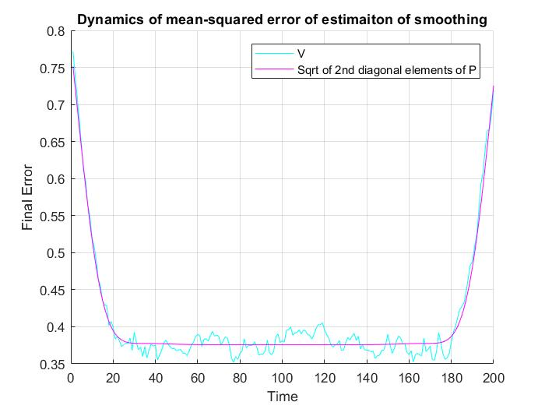

Error is around some small value during almost hole interval of estimation. But it is much higher on first and last steps. First steps have bigger error because of starting error of Kalman filter. Last steps – because of smoothing algorithm itself (the more steps from end – the better is the smoothed estimate).

Velocity smooth estimate are much more accurate, than coordinate estimates. This is because the true trajectory is also smooth, and velocity changes more gradually, than coordinate.

**Conclusion**

Kalman filtration can be developed with backward smoothing. This will increase accuracy of estimation of smooth trajectories (like a trajectory with small random acceleration). Smoothing takes into account both current and future measurements and therefore provides improved estimation. The final estimation can be very precise in the middle of trajectory, however both sides will have a greater error. At the beginning, due to Kalman error. Also, at the ending, because smoothing works from end and uses all previous elements witch increases precision gradually, until saturated.

Files with matlab code are attached.